Yandex.Money registration

Verified on August 23, 2018.

1. To register an account with Yandex, you need to go to https://passport.yandex.com/.
2. Click the "Registration" button. 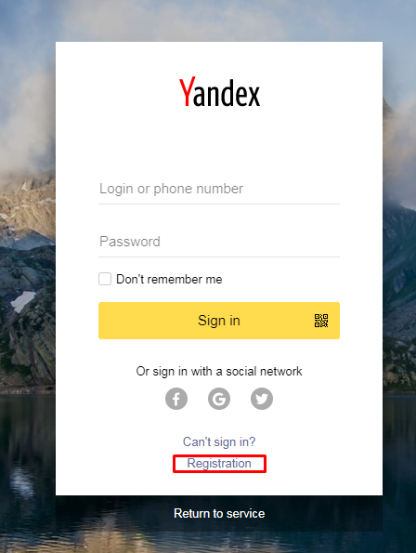
3. In the window that opens, fill out the “Registration” form and click on the “Registrer” button. 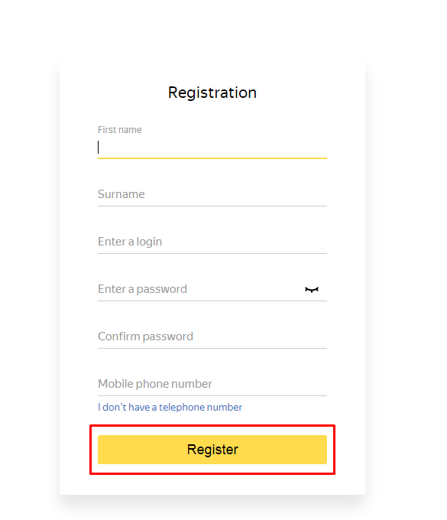
4. Agree with the "Privacy Policy and Terms of Use" and click on the "Accept" button.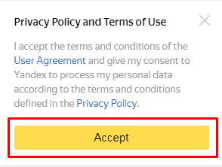

5. After that, your account is registered. You are in the profile settings.

1. To register the application you need to follow the link <https://tech.yandex.com/money/apps/>.
2. On the page that opens, click on the link “”Register your application”.

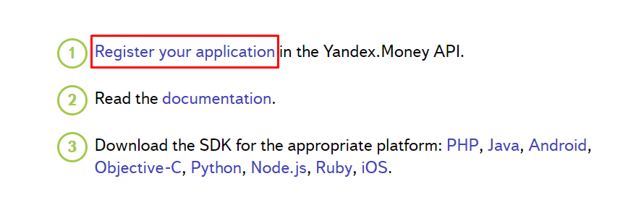

3. Confirm access.

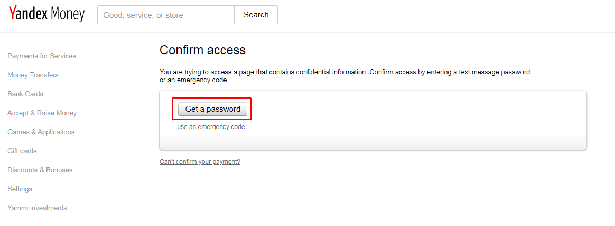

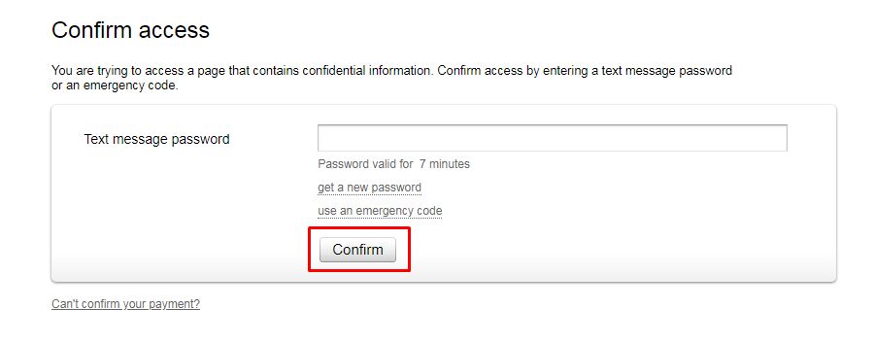

4. In the App registration form, fill in the required fields, check the Apply authenticity check to the App (OAuth2 client_secret) check box and click the "Confirm" button.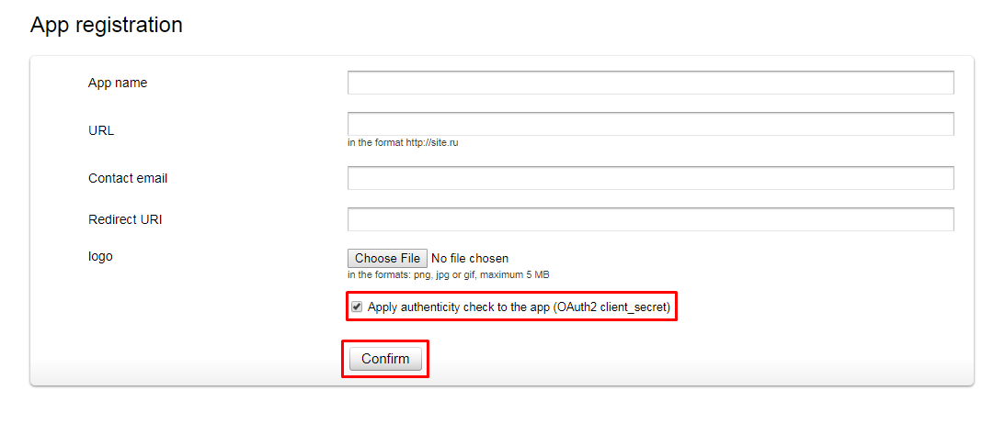

5. On the next page you will see the necessary keys of your application for calling the API.

